**PRAKTIKUM LANJUTAN**

**RECYCLERVIEW MODE GRID**

Pada modul sebelumnya, kita telah membuat menu pada aplikasi daftar Pahlawan yang dibuat dengan mode *list*. Mari kita lanjutkan pembuatan bentuk dari RecyclerView dalam bentuk *grid*.

1. Buat sebuah berkas layout xml baru dengan nama item_grid_hero.

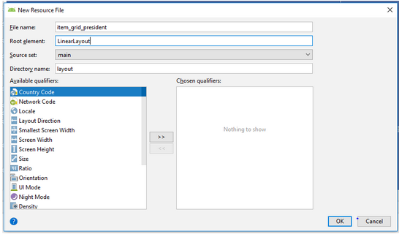

Setelah itu lengkapi kodenya menjadi seperti berikut :

|  |
| --- |
| 1. <?xml version="1.0" encoding="utf-8"?> 2. <LinearLayout xmlns:android="http://schemas.android.com/apk/res/android" 3. xmlns:tools="http://schemas.android.com/tools" 4. android:layout_width="match_parent" 5. android:layout_height="wrap_content" 6. android:orientation="vertical"> 8. **<ImageView** 9. **android:id="@+id/img_item_photo"** 10. **android:layout_width="match_parent"** 11. **android:layout_height="250dp"** 12. **android:layout_margin="1dp"** 13. **android:scaleType="centerCrop"** 14. **tools:src="@color/colorAccent" />** 15. </LinearLayout> |

1. Setelah selesai, lanjut ke pembuatan Adapter untuk berkas layout xml tersebut. Buat sebuah kelas baru dengan nama GridHeroAdapter.

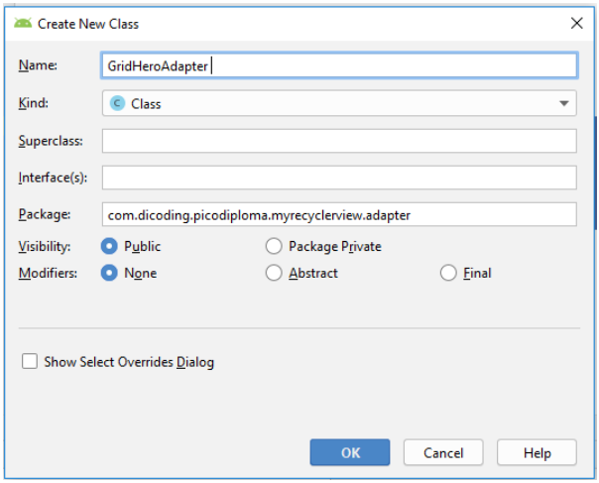

Kemudian lakukan hal yang sama dengan pembuatan ListHeroAdapter, lengkapi kodenya menjadi seperti berikut:

|  |
| --- |
| Java |
| 1. public class GridHeroAdapter **extends RecyclerView.Adapter<GridHeroAdapter.GridViewHolder>**{ 2. } |

|  |
| --- |
| Kotlin |
| 1. class GridHeroAdapter :**RecyclerView.Adapter<GridHeroAdapter.GridViewHolder>**{ 2. } |

Setelah itu kita akan perbaiki eror dengan cara menekan **alt+enter** atau**klik lampu merahnya**. Setelah memperbaiki maka akan menjadi seperi ini:

|  |
| --- |
| 1. public class GridHeroAdapter extends RecyclerView.Adapter<GridHeroAdapter.GridViewHolder> { 2. **@NonNull** 3. **@Override** 4. **public GridViewHolder onCreateViewHolder(@NonNull ViewGroup viewGroup, int i) {** 5. **return null;** 6. **}** 7. **@Override** 8. **public void onBindViewHolder(@NonNull GridViewHolder gridViewHolder, int i) {** 9. **}** 11. **@Override** 12. **public int getItemCount() {** 13. **return 0;** 14. **}** 15. **public class GridViewHolder extends RecyclerView.ViewHolder {** 16. **public GridViewHolder(@NonNull View itemView) {** 17. **super(itemView);** 18. **}** 19. **}** 20. } |

|  |
| --- |
| Kotlin |
| 1. class GridHeroAdapter : RecyclerView.Adapter<GridHeroAdapter.GridViewHolder>() { 2. **override fun onCreateViewHolder(p0: ViewGroup, p1: Int): GridViewHolder {** 3. **TODO("not implemented") //To change body of created functions use File | Settings | File Templates.** 4. **}** 5. **override fun onBindViewHolder(p0: GridViewHolder, p1: Int) {** 6. **TODO("not implemented") //To change body of created functions use File | Settings | File Templates.** 7. **}** 9. **override fun getItemCount(): Int {** 10. **TODO("not implemented") //To change body of created functions use File | Settings | File Templates.** 11. **}** 12. **inner class GridViewHolder(itemView: View) : RecyclerView.ViewHolder(itemView)** 13. } |

Kemudian buatlah **constructor**untuk list seperti ini:

|  |
| --- |
| Java |
| 1. public class GridHeroAdapter extends RecyclerView.Adapter<GridHeroAdapter.GridViewHolder> { 2. **private ArrayList<Hero> listHero;** 3. **public GridHeroAdapter(ArrayList<Hero> list) {** 4. **this.listHero = list;** 5. **}** 7. ... 8. } |

|  |
| --- |
| Kotlin |
| 1. class GridHeroAdapter**(val listHeroes: ArrayList<Hero>)** : RecyclerView.Adapter<GridHeroAdapter.GridViewHolder>() { 2. ... 3. } |

Setelah itu kita bisa melengkapi kode kode hasil dari turunan RecyclerView.Adapter. Maka kode lengkap dari kelas GridHeroAdapter sebagai berikut:

|  |
| --- |
| Java |
| 1. public class GridHeroAdapter extends RecyclerView.Adapter<GridHeroAdapter.GridViewHolder> { 2. private ArrayList<Hero> listHero; 4. public GridHeroAdapter(ArrayList<Hero> list) { 5. this.listHero = list; 6. } 8. @NonNull 9. @Override 10. public GridViewHolder onCreateViewHolder(@NonNull ViewGroup viewGroup, int viewType) { 11. **View view = LayoutInflater.from(viewGroup.getContext()).inflate(R.layout.item_grid_hero, viewGroup, false);** 12. **return new GridViewHolder(view);** 13. } 15. @Override 16. public void onBindViewHolder(@NonNull final GridViewHolder **holder**, int **position**) { 17. **Glide.with(holder.itemView.getContext())** 18. **.load(listHero.get(position).getPhoto())** 19. **.apply(new RequestOptions().override(350, 550))** 20. **.into(holder.imgPhoto);** 21. } 23. @Override 24. public int getItemCount() { 25. **return listHero.size();** 26. } 28. class GridViewHolder extends RecyclerView.ViewHolder { 29. **ImageView imgPhoto;** 31. GridViewHolder(View itemView) { 32. super(itemView); 33. **imgPhoto = itemView.findViewById(R.id.img_item_photo);** 34. } 35. } 36. } |

|  |
| --- |
| Kotlin |
| 1. class GridHeroAdapter(val listHeroes: ArrayList<Hero>) : RecyclerView.Adapter<GridHeroAdapter.GridViewHolder>() { 3. override fun onCreateViewHolder(viewGroup: ViewGroup, i: Int): GridViewHolder { 4. val view: View = LayoutInflater.from(viewGroup.context).inflate(R.layout.item_grid_hero, viewGroup, false) 5. return GridViewHolder(view) 6. } 8. override fun onBindViewHolder(**holder**: GridViewHolder, **position**: Int) { 9. **Glide.with(holder.itemView.context)** 10. **.load(listHeroes[position].photo)** 11. **.apply(RequestOptions().override(350, 550))** 12. **.into(holder.imgPhoto)** 13. } 15. override fun getItemCount(): Int { 16. **return listHeroes.size** 17. } 19. inner class GridViewHolder(itemView: View) : RecyclerView.ViewHolder(itemView) { 20. **var imgPhoto: ImageView = itemView.findViewById(R.id.img_item_photo)** 21. } 22. } |

1. Setelah semuanya selesai, mari kita pasang lagi di MainActivity dengan menambahkan satu metode berikut:

|  |
| --- |
| Java |
| 1. **private void showRecyclerGrid(){** 2. **rvHeroes.setLayoutManager(new GridLayoutManager(this, 2));** 3. **GridHeroAdapter gridHeroAdapter = new GridHeroAdapter(list);** 4. **rvHeroes.setAdapter(gridHeroAdapter);** 5. **}** |

|  |
| --- |
| Kotlin |
| 1. **private fun showRecyclerGrid() {** 2. **rvHeroes.layoutManager = GridLayoutManager(this, 2)** 3. **val gridHeroAdapter = GridHeroAdapter(list)** 4. **rvHeroes.adapter = gridHeroAdapter** 5. **}** |

Dan lengkapi metode onOptionItemSelected() menjadi seperti berikut:

|  |
| --- |
| Java |
| 1. public void setMode(int selectedMode) { 2. switch (selectedMode) { 3. case R.id.action_list: 4. **showRecyclerList();** 5. break; 7. case R.id.action_grid: 8. **showRecyclerGrid();** 9. break; 11. case R.id.action_cardview: 13. break; 14. } 15. } |

|  |
| --- |
| Kotlin |
| 1. private fun setMode(selectedMode: Int) { 2. when (selectedMode) { 3. R.id.action_list -> { 4. **showRecyclerList()** 5. } 7. R.id.action_grid -> { 8. **showRecyclerGrid()** 9. } 11. R.id.action_cardview -> { 13. } 14. } 15. } |

1. Ini akan mengubah tampilan ketika pengguna memilih salah satu bentuk layout. Sekarang jalankan kembali aplikasinya. Akan ada dua bentuk dariRecyclerView yaitu list dan grid.

